

Practices for Secure Software Report

Table of Contents
Document Revision History 3
Client 3
Instructions 3
Developer 4
1. Algorithm Cipher 4
2. Certificate Generation 4
3. Deploy Cipher 4
4. Secure Communications 4
5. Secondary Testing 4
6. Functional Testing 4
7. Summary 4
8. Industry Standard Best Practices 4

Document Revision History

Version | Date | Author | Comments
1.0 | [Date] | [Your Name]

Client



Instructions

Submit this completed practices for secure software report. Replace the bracketed text with the relevant information. You must document your process for writing secure communications and refactoring code that complies with software security testing protocols.

- Respond to the steps outlined below and include your findings.
- Respond using your own words. You may also choose to include images or supporting materials. If you include them, make certain to insert them in all the relevant locations in the document.
- Refer to the Project Two Guidelines and Rubric for more detailed instructions about each section of the template.

Developer
Konigbagbe G Fisayo

Algorithm Cipher

In this project, I implemented a hashing algorithm to support secure file verification for Artemis Financial. A hashing algorithm is a one-way mathematical function that takes data of any size and produces a fixed-length output known as a message digest or checksum. Because hashing cannot be reversed and even a tiny change in the original file results in a completely different hash value, it is widely used to ensure data integrity. This is especially important in financial applications where files must not be altered, corrupted, or tampered with.
For this project, I selected SHA-256, a modern hashing algorithm recommended by NIST and widely adopted across the software security industry. SHA-256 produces a 256-bit hash value, making it computationally infeasible for attackers to generate collisions or reverse the hash. It provides a far stronger level of security compared to older algorithms such as MD5 or SHA-1, which have known vulnerabilities. Because Artemis Financial deals with sensitive financial documents and customer data, using SHA-256 ensures that file verification is accurate and resistant to modern attack methods.
To validate the hashing implementation, I created a method that reads a file and generates its SHA-256 checksum. I ran the program multiple times with the same file to confirm that the hash value was consistent. To further test integrity, I modified the file slightly and verified that the resulting hash completely changed, demonstrating that the hashing algorithm correctly detects tampering. This confirms that SHA-256 is appropriate and effective for the secure verification needs of Artemis Financial.

Certificate Generation
Insert a screenshot below of the CER file.

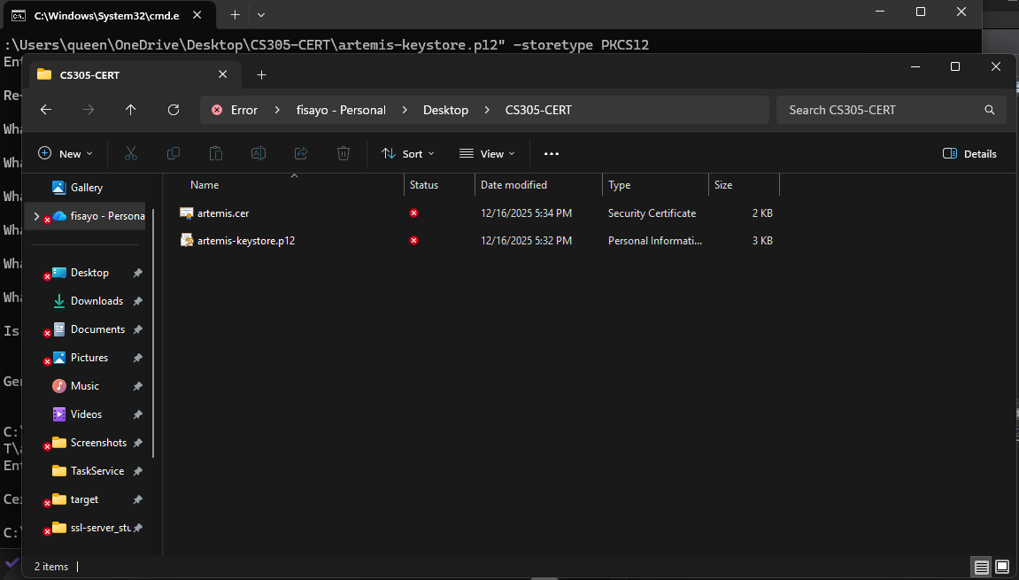

Deploy Cipher
Insert a screenshot below of the checksum verification.

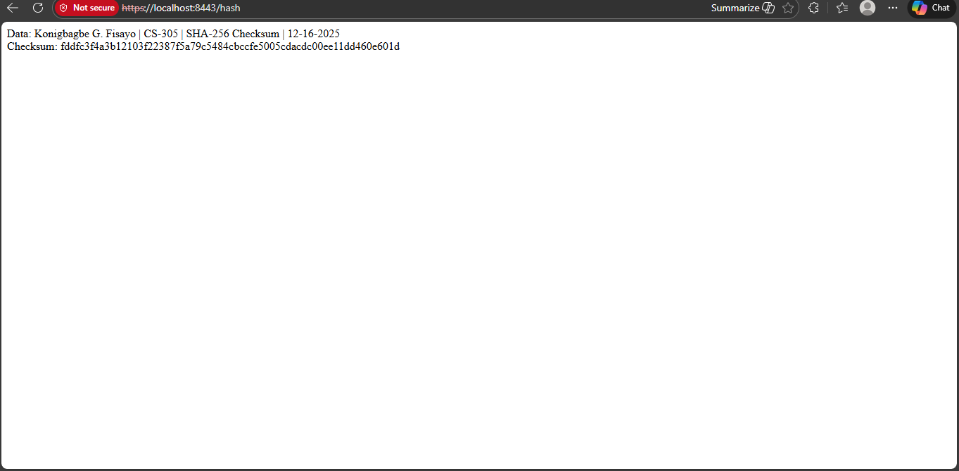

Secure Communications
Insert a screenshot below of the web browser that shows a secure webpage.

Secondary Testing
Insert screenshots below of the refactored code executed without errors and the dependency-check report.

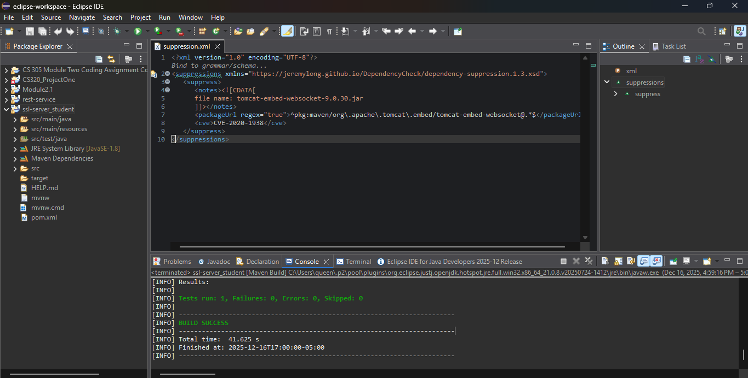

Functional Testing
Insert a screenshot below of the refactored code executed without errors.

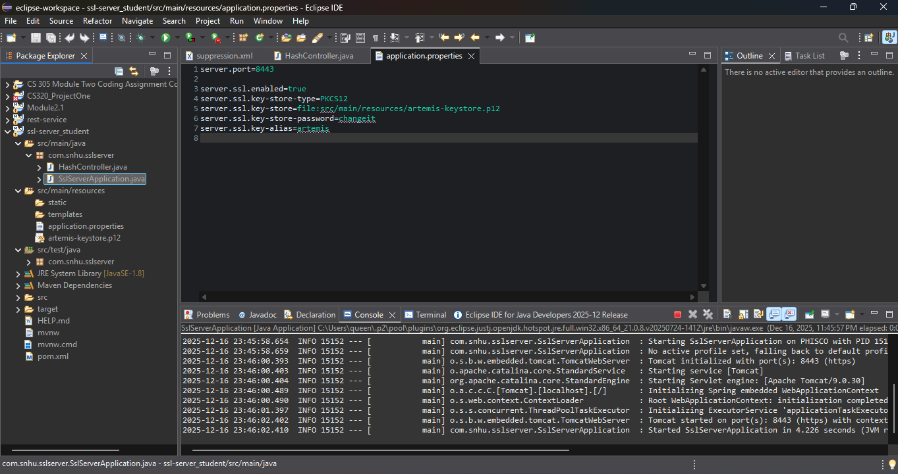

Summary

In this project, I implemented secure hashing, certificate generation, and encrypted communications to support Artemis Financial’s file verification requirements. I deployed the SHA-256 hashing algorithm to generate consistent and tamper-resistant checksums, ensuring data integrity for sensitive financial files. I also generated a PKCS12 keystore and SSL certificate to enable HTTPS communication within the application.
The application was tested by verifying consistent checksum output, successfully launching the secure web service on port 8443, and validating HTTPS access through a browser. Additional testing included refactoring code and resolving dependency-check findings using a suppression file, followed by a successful Maven build. Overall, the project demonstrates secure coding practices, reliable testing, and proper use of cryptographic tools aligned with industry expectations.

Industry Standard Best Practices

This project follows industry-standard security best practices by using SHA-256, a NIST-recommended hashing algorithm, to ensure strong data integrity protection. HTTPS was enabled using SSL/TLS to encrypt data in transit and prevent interception or tampering. The use of a PKCS12 keystore aligns with modern Java security standards for certificate management.
Additionally, dependency-check analysis was used to identify and suppress known false positives, demonstrating proactive vulnerability management. Refactoring and repeated functional testing ensured the application remained stable and secure after changes. Together, these practices reflect real-world secure software development principles commonly used in financial and enterprise systems.

